Math Problem of the Week

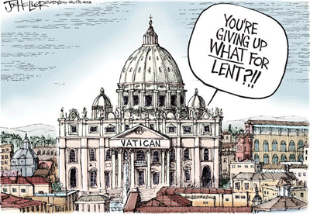

The Conclave is set to begin sometime after February 28, 2013,

the final day of Benedict XVI’ papacy. There are 117 Cardinals

traveling to Rome to take part in the Conclave. If the next pope

needs a 2/3 of the votes from the secret ballot, what number of

Cardinals does this actually represent?

Use numbers, words and pictures to make your math thinking known.